Spending Project

Amount:

These are the guidelines:

You must spend ALL of your money, NOT a penny over NOT a penny under.

You must use some of the money for specific things. Below is a list of items that are suggested, as well as a list that you MUST spend the money on.

As you complete each item, check it off on the table. You must show proof of everything you purchase. Every item must have a value to it, along with a picture of the item.

If you are unsure of an item or have questions, please run it by me before the final project is due.
(Remember you need a picture of the items and their cost)
They can be presented in PowerPoint from your OneDrive. Or it can be presented on a poster

Check List

Check off as completed

Must Do Suggestions
- Clothing

- Pets and their supplies they require

- Electronics :
TV
Cell phone
Computer
iPad
game console
iPods
Speakers

- Entertainment:
Sports Events Tickets
Concert Tickets

- Furniture

- Gym membership

- Jewelry and Accessories

- Pool and Landscaping

- Put money in savings account.

- Put money away for college.

- A place to live:
House
Condo
Apartment

- Donate money to charity.

- Find pictures and/or prices from the newspaper, flyers, magazines, catalogs, online etc.

- You will also need food for the next two months.

- You may only purchase up to three (3) of the same item.

- Use the tally sheet to total up your expenses. List a grand total on the last sheet. You will need to use a calculator.

- Design an attractive poster/PowerPoint for your project

- Present your project and discuss your expenses to the class.

- You will also need to include the website used.

Scoring Rubric for Spending Project

- Presentation 0 10 15 18 20

- Detailed Presentation 0 10 15 18 20

- Spreadsheet 0 10 15 18 20

- Spending all your money 0 25

- Following ALL directions 0 5 10 12 15

Total: /100 points possible

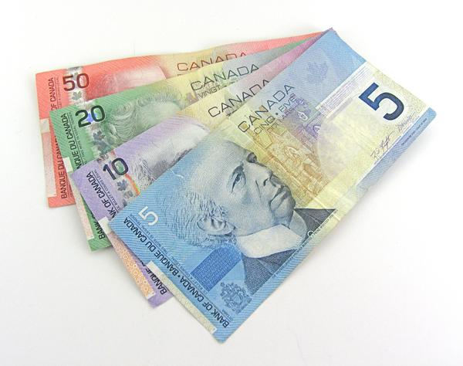
This Photo by Unknown Author is licensed under CC BY-SA-NC

***Before presenting your project, in this order staple:
- Scoring rubric
- Check list
- Tally sheet

